**HungerMate Feature 2 User Guide**

**By:**

**Christopher Mendoza**

**Haricharan Mukthineni**

**Gabriel Braun**

**For:**

**SWEN 5239.32 Agile Software Development**

**Dr. Soma Datta**

**April 22nd, 2024**

**Contents**

Main Menu………………………………………………………………………………………………2

Filter Restaurants Menu……………………………………………………………………………….3

Restaurant Selection…………………………………………………………………………………..4

View Restaurant Menu………………………………………………………………………………...5

Selection and Customizations of Items………………………………………………………………6

**Main Menu**

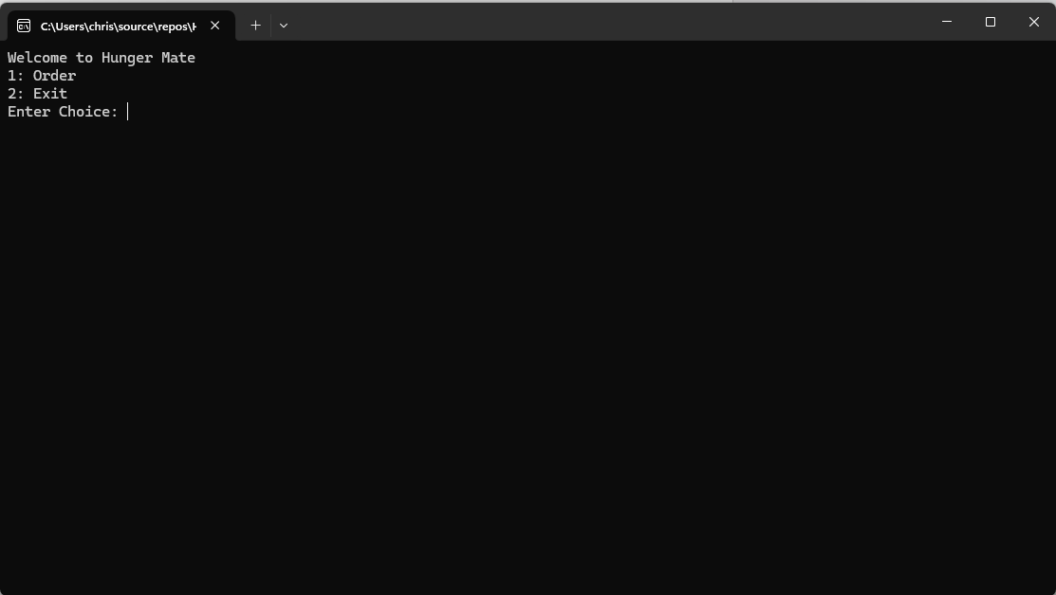

The main menu allows the user to input whether they are ready to place and order or exit the application.

**Restaurant Filter Menu**

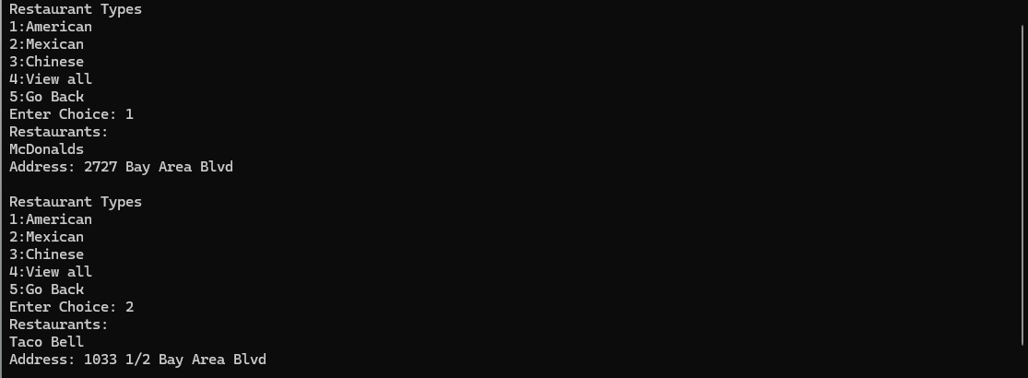

The Restaurant Filter menu allows the user to select the type of cuisine they are looking for and the application will print the restaurants of that type. The user can also select to view all restaurants or to go back to the main menu.

**Restaurant Selection**

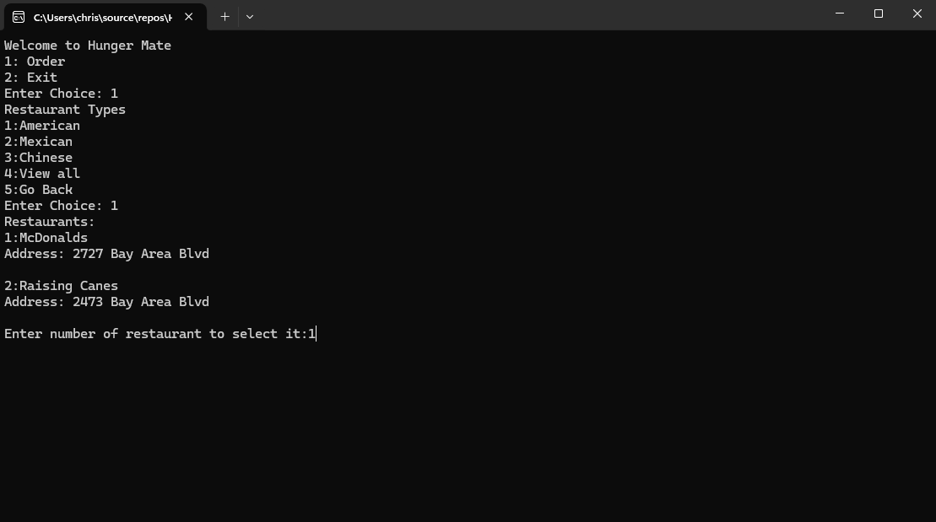

Users are prompted to enter the number of the restaurant they wish to select. Entering a wrong number will display an error message. Correct choice will take the user to view the menu of the restaurant.

**View Restaurant Menu**

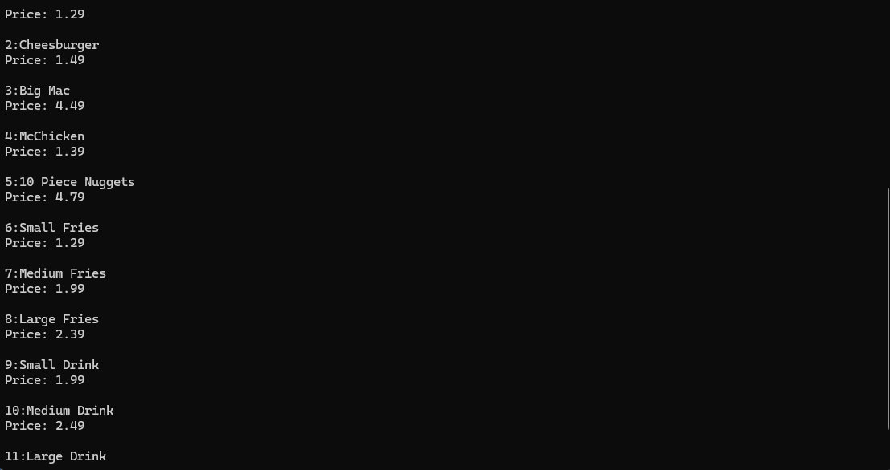

After selection of the restaurant a menu of items available is displayed to the user. This menu shows the item number, item name, and item price.

**Selection and Customizations of Items**

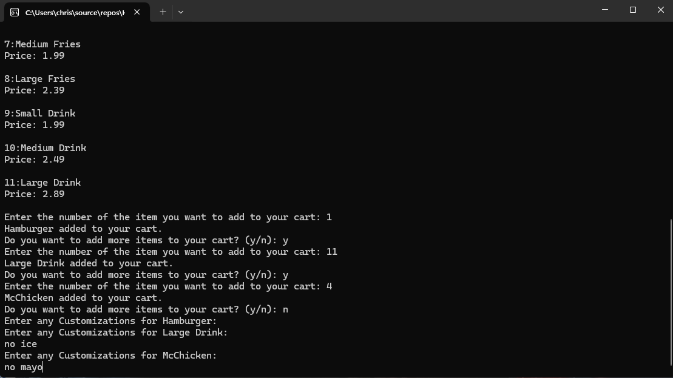

Users receive a prompt to enter the number of items they wish to select. A success message is displayed after each input. User is then asked to continue adding more items or no stop. Once the user selects to stop they will be asked to enter customizations they would like.